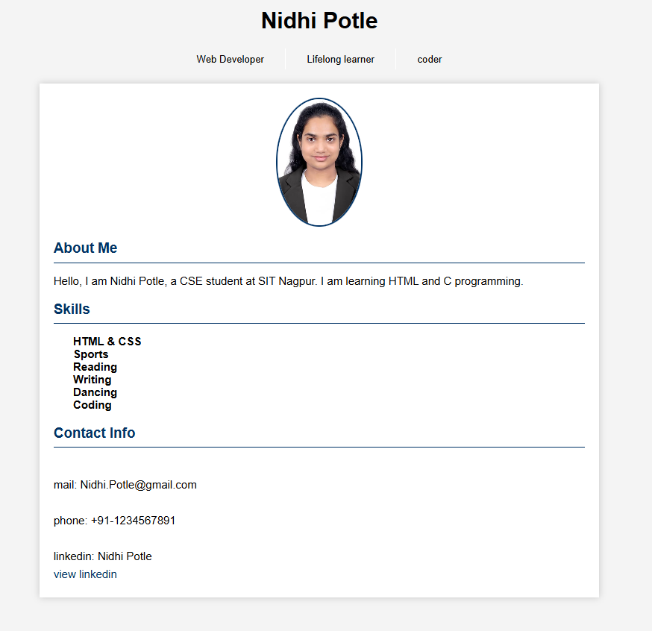
Practical 6 HTML
<!DOCTYPE html>
<html lang="en">
<head>
<meta charset="UTF-8">
<meta name="viewport" content="width=device-width, initial-scale=1.0">
<title>Nidhi Potle - Profile</title>
<style>
body {
margin: 0;
font-family: Arial, sans-serif;
background-color: #f4f4f4;
}

header {
background-color: #003366;
color: white;
text-align: center;
padding: 3px 20px 40px 20px;
}

header h1 {
margin: 0;
font-size: 28px;
}

.header-info {
display: flex;
justify-content: center;
align-items: center;
margin-top: 20px;
gap: 30px;
}

.info-item {
font-size: 14px;
}

.v-line {
width: 1.5px;
height: 30px;
background-color: white;
}

.profile-box {
background-color: white;
max-width: 800px;
margin: 20px auto;
box-shadow: 0 0 10px rgba(0,0,0,0.2);
box-sizing: border-box;
padding: 20px; /* Added padding to ensure content isn't flush with the box */
}

.profile-photo {
display: block;
margin: 0 auto 20px;
width: 120px;
height: 180px;
border-radius: 50%;
object-fit: cover;
border: 3px solid #003366;
}

.section-title {
color: #003366;
font-weight: bold;
font-size: 20px;
margin-top: 20px;
}

.blue-line {
border: none;
border-top: 2px solid #003366;
margin: 8px 0 15px;
width: 100%;
}

ul {
padding-left: 20px;
list-style-type: none; /* A common style for cleaner CV/Profile lists, though not specified */
}

ul li {
margin-left: 8px; /* Corrected from margin-left: 8px font-weight: bold; */
font-weight: bold;
}

.contact-info {
margin-top: 10px;
line-height: 1.6;
}

.contact-info a {
color: #003366;
text-decoration: none;
}
</style>
</head>
<body>

<div class="header">
<h1 style="text-align: center;">Nidhi Potle</h1>
<div class="header-info">
<div class="info-item">Web Developer</div>
<div class="v-line"></div>
<div class="info-item">Lifelong learner</div>
<div class="v-line"></div>
<div class="info-item">coder</div>
</div>
</div>

<div class="profile-box">
<img src="C:\Users\NIDHI\Downloads\photo.jpeg" " alt="Photo of Nidhi Potle" class="profile-photo">

<div class="section-title">About Me</div>
<hr class="blue-line"/>
<p>
Hello, I am Nidhi Potle, a CSE student at SIT Nagpur. I am learning HTML and C programming.
</p>

<div class="section-title">Skills</div>
<hr class="blue-line"/>
<ul>
<li>HTML & CSS</li>
<li>Sports</li>
<li>Reading</li>
<li>Writing</li>
<li>Dancing</li>
<li>Coding</li>
</ul>

<div class="section-title">Contact Info</div>
<hr class="blue-line"/>
<div class="contact-info">
<br>mail: Nidhi.Potle@gmail.com<br>
<br>phone: +91-1234567891<br>
<br>linkedin: Nidhi Potle<br>
<a href="https://....." target="_blank">view linkedin</a>
</div>
</div>

</body>
</html>

